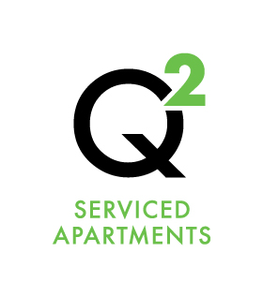 | Internet Access

Your room is setup for free wireless access.

Instructions on how to Access the Internet from your room.

- Logging On
  - Go to Wi-Fi Settings and select Qsquared from the list of available wireless networks.
  - Enter the WiFi password you were supplied with upon check-in.

- Limits
  - You have a free daily limit of 2 GB – if you exceed this, you will be disabled and will have to wait 24 hours the device to reset.
  - 2 GB is adequate for general browsing but will used up quickly if downloading or streaming.
  - Be aware that having an app like Dropbox will use up a lot of data uploading photos so you may want to turn that off to save data.
  - No illegal or anti-social activities will be tolerated while using Q Squared Serviced Apartments Internet Access.

- Trouble Shooting
  - Some operating systems may require you to turn the Pop-Up blocker off – Internet Explorer > Tools/Options > Privacy Tab > Set Pop-Up blocker to Off.

Any problems logging on – please see reception.

