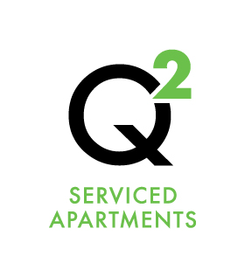 | Emergencies

If you require emergency assistance outside of normal reception hours then the Emergency number can be located on the reception window outside the building on the ramp next to the access panel – 115 Chetwynd St.

- Only contact the emergency number outside of Reception hours in an Emergency
  - An Emergency may include being locked out of your apartment or a burst water main etc.
- Do not call the Emergency number for minor issues that can wait until the following day when reception is open
- Any callouts requiring on site attendance will be charged a $100 fee if deemed to be the fault of the guest e.g. locked yourself out of the apartment.
- Any calls that are not deemed an emergency – you will be told to see reception the next day
  - Running out of coffee, fresh towels etc. are not considered emergencies
- Any other emergencies, that is, those that poses an immediate risk to health, life, property, or environment – call 000

Please be aware that we are Apartments – we are not a Hotel, we do not have 24 hour reception and cannot replace amenities after reception is closed.

